Car Insurance Claim Prediction
Student Name: Niketa
Course: Data Science
Batch ID: DS-C-WD-E-B55
Mentor: Harshvardhan Palawat
Domain: Insurance/ Finance/ Rish Analysis
Tools Used: Python (VS Code), Scikit-Learn, Streamlit, Pandas, Plotly.

1. Problem Statement
The objective is to build a predictive model that determines whether a customer will make a car insurance claim in the next policy period. This is a binary classification problem (is_claim: 0 or 1) based on demographic, vehicle, and policy-related features.

2. Business Use Case
Insurance companies lose significant revenue due to high-risk profiles. Predicting claims allows the business to:
- Identify High-Risk Customers: Tailor policy pricing based on risk.
- Operational Efficiency: Pre-allocate resources for claim settlements.
- Customer Retention: Offer better rates to low-risk customers identified by the model.

3. Project Architecture
The project is built using a modular approach to ensure scalability and reproducibility:
- eda.ipynb: Interactive data exploration and visualization.
- preprocessing.py: Data cleaning, Label Encoding, and Feature Scaling.
- train.py: Model selection, Hyperparameter tuning (GridSearchCV), and evaluation.
- Streamlit_app.py: Deployment of a web-based dashboard for analysis and real-time prediction.

4. Data Description
The dataset consists of three main components:
- Train Data: Includes features like policy_tenure, age_of_car, ncap_rating, and the target variable is_claim.
- Test Data: Used for final model evaluation.
Key Features:
- Demographics: age_of_policyholder, population_density, area_cluster.
- Vehicle Specs: fuel_type, engine_type, airbags, displacement, ncap_rating.
- Policy Info: policy_tenure.

5. Approach & Methodology
5.1 Exploratory Data Analysis (EDA)
Performed using eda.ipynb. Key insights discovered using matplotlib and seaborn:
- Class Imbalance: Checked the ratio of claims vs. non-claims.
- Correlation: Analyzed how car age and policyholder age influence claim probability.
- Visualizations: Used Plotly to create interactive charts showing claim distribution across different area_clusters and fuel_types.

we generated 10 key visualizations to understand the data:
- Target Distribution: Identified a significant class imbalance (more non-claims than claims).
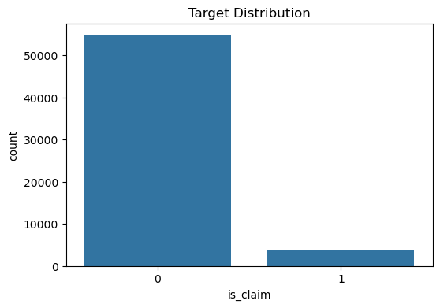
- Age of Policyholder: Observed the density of policyholders across different age groups.

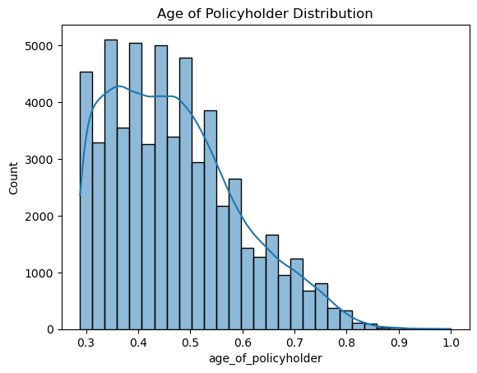

- Age of Car: Analyzed how new vs. old cars relate to claim frequency.

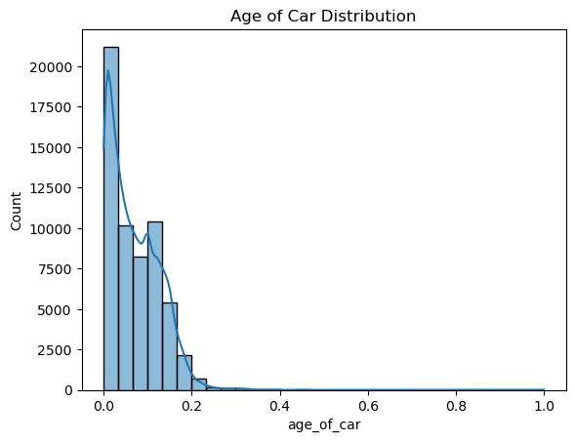

- Policy Tenure vs. Claim: Boxplots revealed that longer tenures correlate with specific claim patterns.

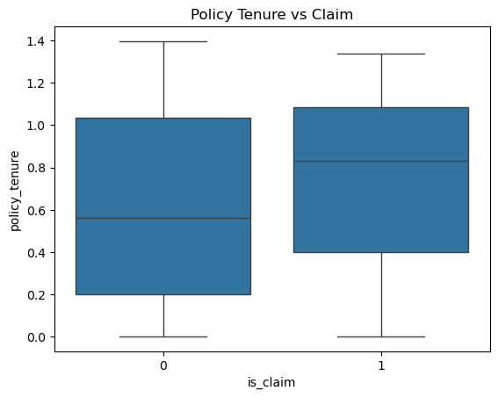

- Fuel Type vs. Claim: Categorical analysis of CNG, Petrol, and Diesel performance.
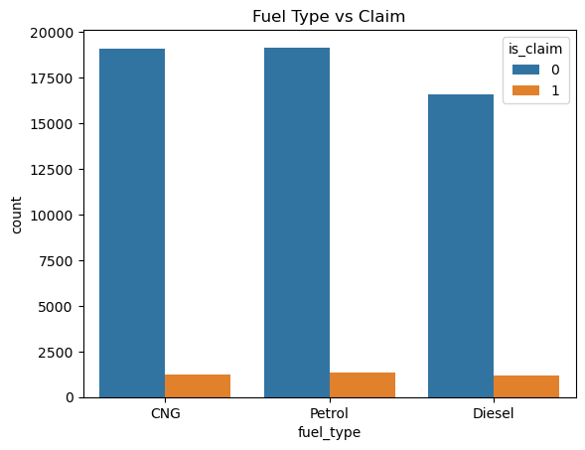

- Car Segment: Distribution of claims across segments (A, B1, B2, etc.).

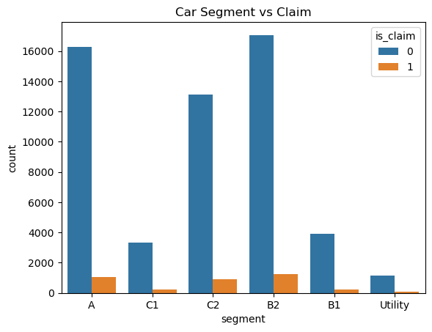

- Transmission Type: Compared Manual vs. Automatic claim rates.

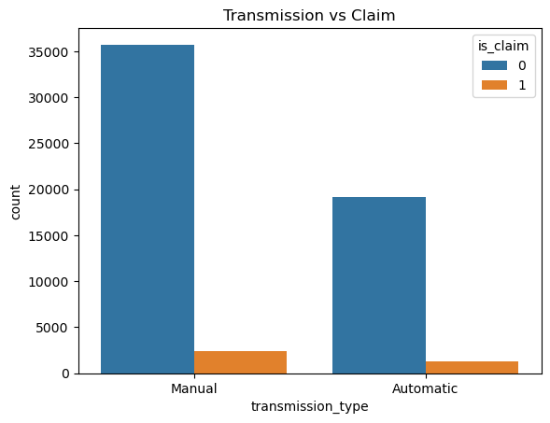

- NCAP Rating: Evaluated if higher safety ratings lead to fewer claims.

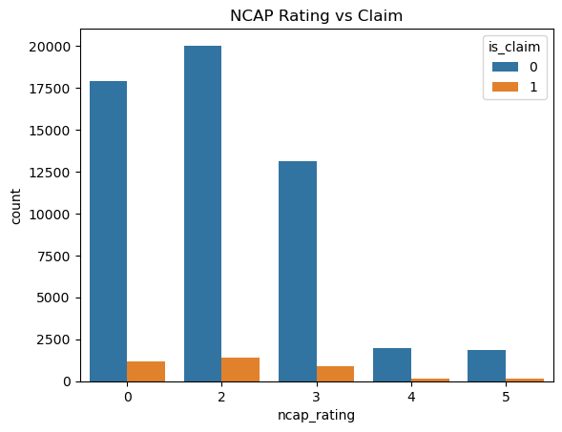

- Population Density vs. Age: Scatter plot to find geographical/demographic clusters.

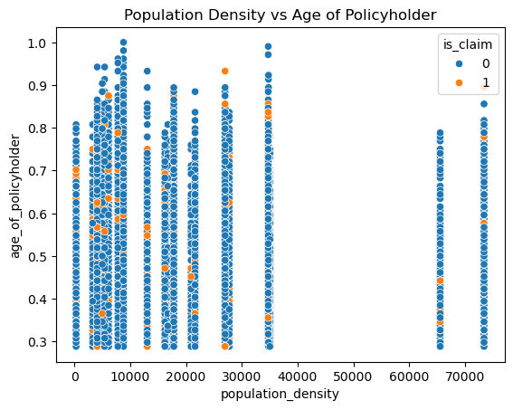

- Correlation Heatmap: Visualized multicollinearity between numerical features like engine displacement and weight.

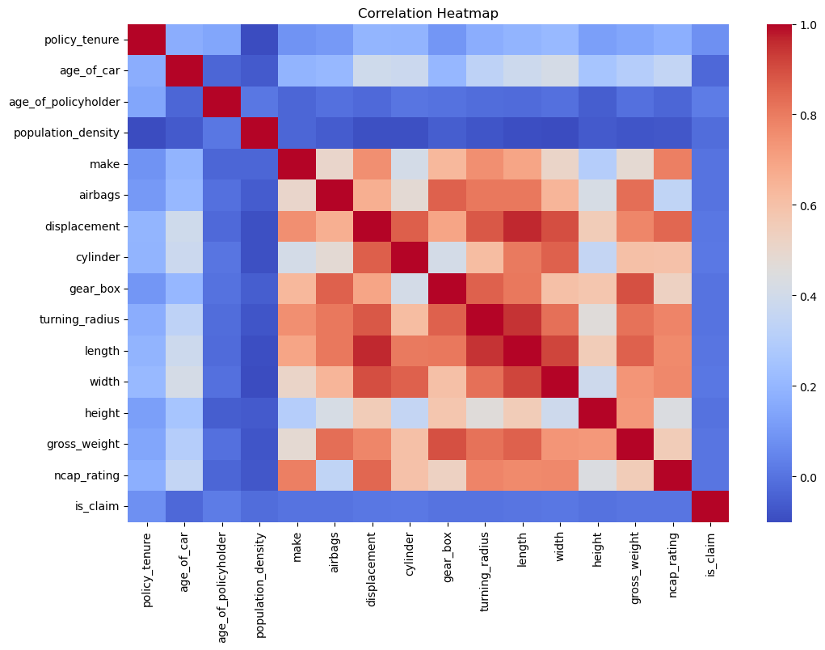
6. Technical Implementation
6.1 Data Preprocessing
- Encoding: Categorical features were converted using LabelEncoder.
- Scaling: All numerical features were standardized using StandardScaler to ensure models like Logistic Regression and XGBoost perform optimally.
- Modularity: Preprocessing logic was encapsulated in a function to handle both training and real-time inference data.

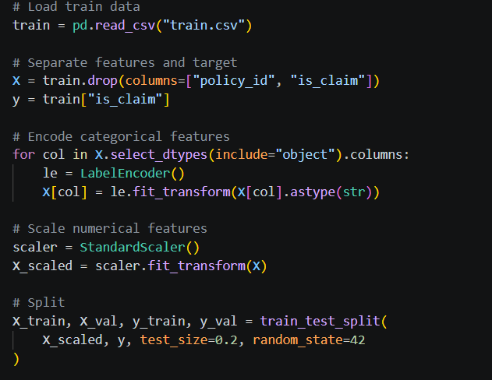
6.2 Model Training & Hyperparameter Tuning
We implemented five different algorithms with GridSearchCV for robust performance:
- Baseline: Logistic Regression & Decision Tree.
- Ensemble: Random Forest.
- Boosting: XGBoost & LightGBM.

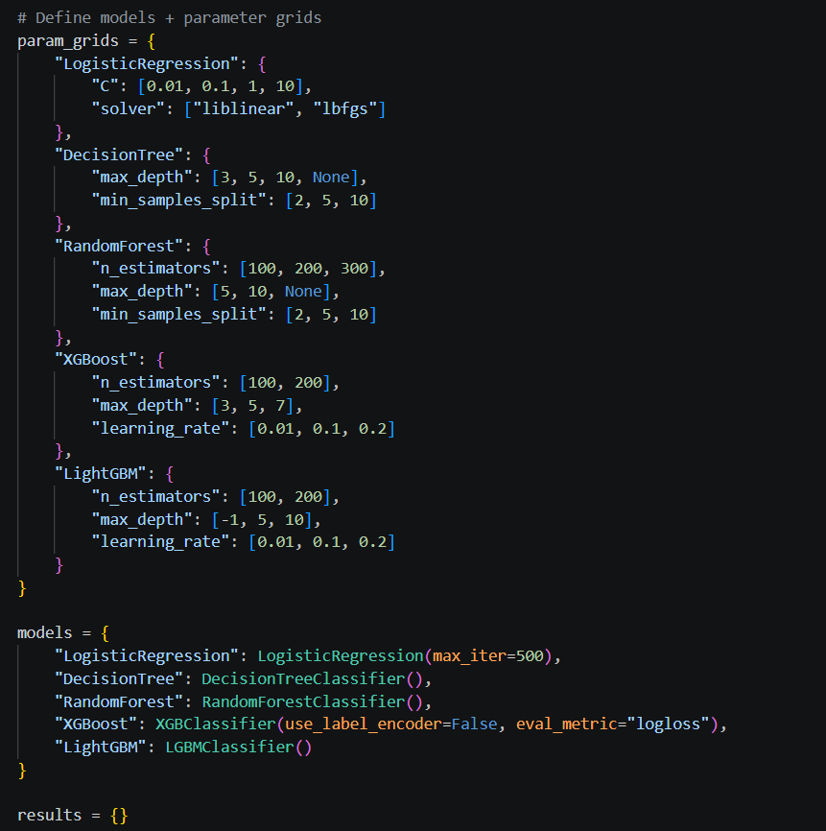

- Evaluation Metrics used: Accuracy, Precision, Recall, F1-Score, and ROC-AUC (primary metric for model selection).
  - The Best Performing Model
  - Model Selection: LightGBM is selected as the final production model.
  - It achieved the highest ROC-AUC (0.6482) and the lowest LogLoss (0.2325). In insurance claim prediction, where class imbalance is high, ROC-AUC is a more reliable metric than simple Accuracy.

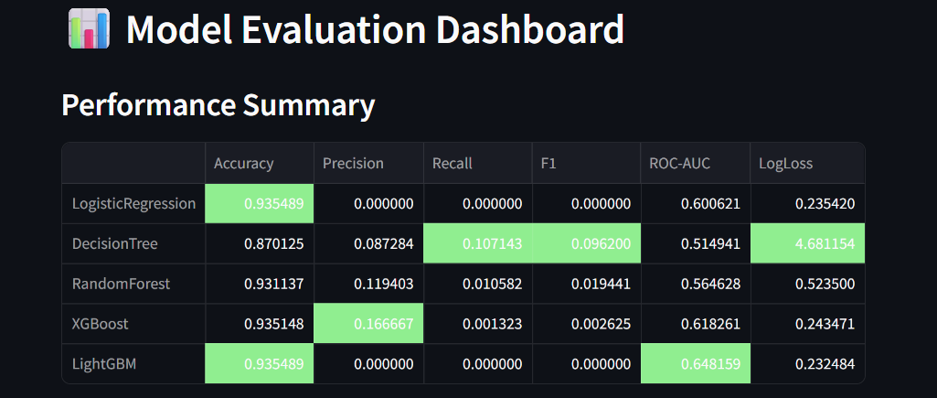
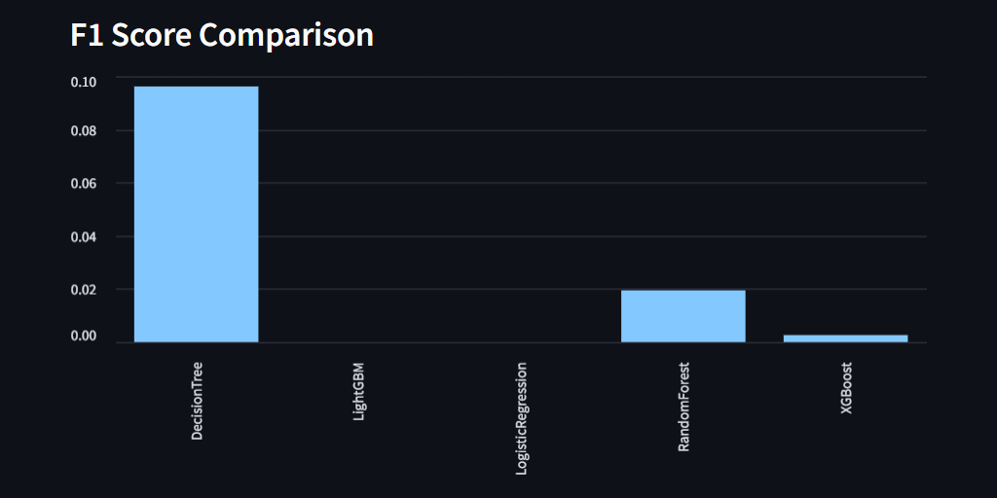

7. Technical Analysis of Results
7.1 The Best Performing Model
Model Selection: LightGBM is selected as the final production model.
Why? It achieved the highest ROC-AUC (0.6482) and the lowest LogLoss (0.2325). In insurance claim prediction, where class imbalance is high, ROC-AUC is a more reliable metric than simple Accuracy.
7.2 Addressing the Class Imbalance
- High Accuracy vs. Low Recall: You will notice models like Logistic Regression and LightGBM show 93.5% Accuracy but 0 Recall. This indicates a massive class imbalance where the model is biased toward predicting "No Claim" (the majority class).
- Decision Tree Performance: The Decision Tree had the highest Recall (0.1071), meaning it was the "bravest" at catching actual claims, but it suffered from the highest LogLoss (4.6811), indicating high uncertainty in its predictions.
- XGBoost Balance: XGBoost showed the best Precision (0.1667), meaning when it did predict a claim, it was more likely to be correct than other models.

8. Deployment (Streamlit)
The application is structured into three main sections:
1. Introduction: Overview of the project and models used.

2. Analysis:
  - Dynamic metrics table highlighting the best-performing model.
  - F1-Score comparison bar charts.
  - Heatmaps of model performance and Confusion Matrices for error analysis.

3. Prediction:
  - Users can select a policy_id from the sample_submission.csv.
  - The app fetches real-time data from test.csv, processes it, and displays the Claim Probability.

9. Conclusion & Results
- Best Model: The model with the highest ROC-AUC was saved as final_model.pkl.
- Coding Standards: Followed PEP8 conventions, used modular functions, and maintained reproducibility by fixing random_state=42.
- Business Impact: The model allows the insurance provider to identify high-risk policyholders early, enabling better premium pricing and risk mitigation.

10. Limitations and Potential Improvements:
Class Imbalance: The heatmap and countplots show that "No Claim" cases far outnumber "Claim" cases. While ROC-AUC was used to mitigate this, future versions could implement SMOTE (Synthetic Minority Over-sampling Technique) to balance the training data.
Feature Engineering: Given the high correlation between car dimensions, we could create a new feature like "Vehicle Volume" ( length * width * height) to simplify the model.
Non-Linearity: Since the correlation with is_claim is low, exploring deep learning or more extensive hyperparameter tuning for Gradient Boosting models might capture deeper patterns.

11. Final Conclusion
The project successfully implemented a machine learning pipeline from raw CSV data to a deployed Streamlit application. LightGBM emerged as the superior model for handling the complex, non-linear relationships in the car insurance dataset. This tool provides a foundation for the insurance company to automate risk assessment and optimize policy pricing.

